Space Diplomat - "Affect-Driven Reinforcement Learning in Strategy Game AI for Procedural NPC Interactions"

- Game Concept Overview
Title: Space Diplomat
Core Genre: Isometric and first-person perspective narrative-driven strategy game, with affective AI-driven dialogue
Setting: The player is a human astronaut diplomat traveling to a distant planetary system to negotiate with alien leaders. The primary goal is to establish peaceful and collaborative relationships between Earth and these civilizations through meaningful, emotion-sensitive dialogues.

- Game Features and Mechanics
2.1. Player Navigation
- Player starts inside the main base room of the spaceship, with a planetary system map (which connects with planetary system map), and the panel for chat (asset from https://assetstore.unity.com/packages/3d/environments/sci-fi/scifi-modular-scenario-pack-320016), and we play using a first-person perspective.
- When going to system map, we get into spaceship view with movement between planets using realistic space physics (rigid body forces, inertia).
- Isometric camera view, Unity URP for stylized lighting and VFX.
- https://www.youtube.com/watch?v=59RBOBbeJaA&ab_channel=SoloGameDev

2.2. Planet Interaction Interface
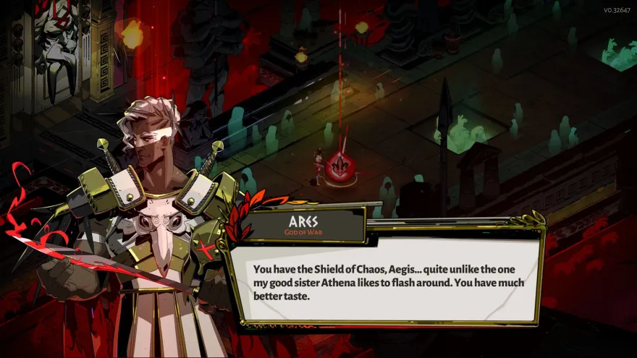
- Visual UI inspired by Hades

- Left Panel: Animated 2D alien leader portrait (Unity Animator)
- Right Panel: Player text input box (limited characters, filtered context)
- Center: Response bubble for the alien's reply
2.3. Conversation Mechanics
- Player inputs dialogue text (capped character limit)
- Text filtered using:
  - Whitelisting Dictionary for context-appropriate terms
  - LLM-based classifier to flag off-topic or inappropriate queries
- Alien replies generated via:
  - RL + GOAP + LLM-based dialogue engine
  - Each planet/leader has distinct emotional models
  - One control leader uses scripted branching dialogue (baseline)

2.4. Emotion Simulation System
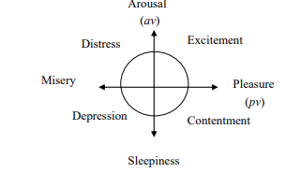
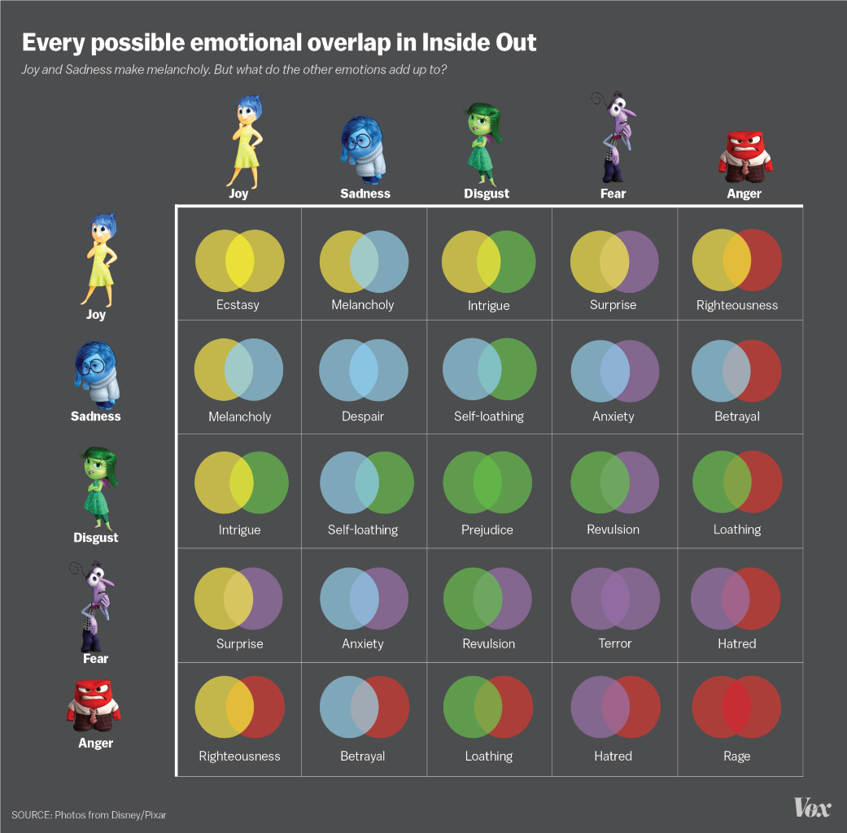
- Inspired by Inside Out and PAD model (Disgust column and row discarded)

- Emotional states: Joy, Sadness, Anger, Disgust, Fear
- Emotions stored as weighted values, updated via:
  - Dialogue content (reinforced or penalized sentiment)
  - Tone analysis (valence/arousal parsing from player input)
- The Alien emotion determines:
  - Visual changes (animation state)
  - Dialogue tone/politeness
  - Final decision (alliance vs hostility)
- Visual change animations for emotions like otome video game types:

- Alien conversation should be attached to emotions, a temperature (randomness), and max tokens. If max tokens cut mid-sentence, use a split function by “.”, “!”, or “?” to determine next stop on sentence and print until next point.
- Alien should have a specific personality and should detect the human user personality. For simpleness, I decided to combine “Neuroticism” and “Agreeableness” in one personality, and “Extraversion” and “Openness” into another personality.

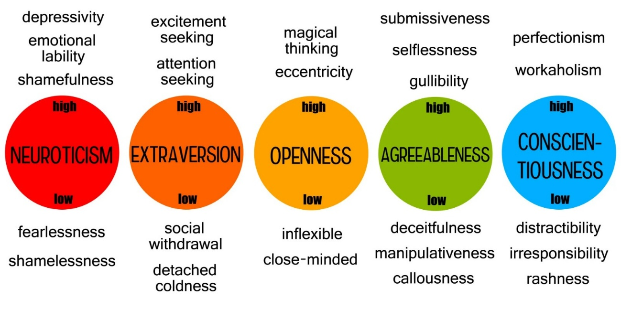
2.5. Pause Menu / Emotional Dashboard
- UI layout like Baldur's Gate 3 inventory screen
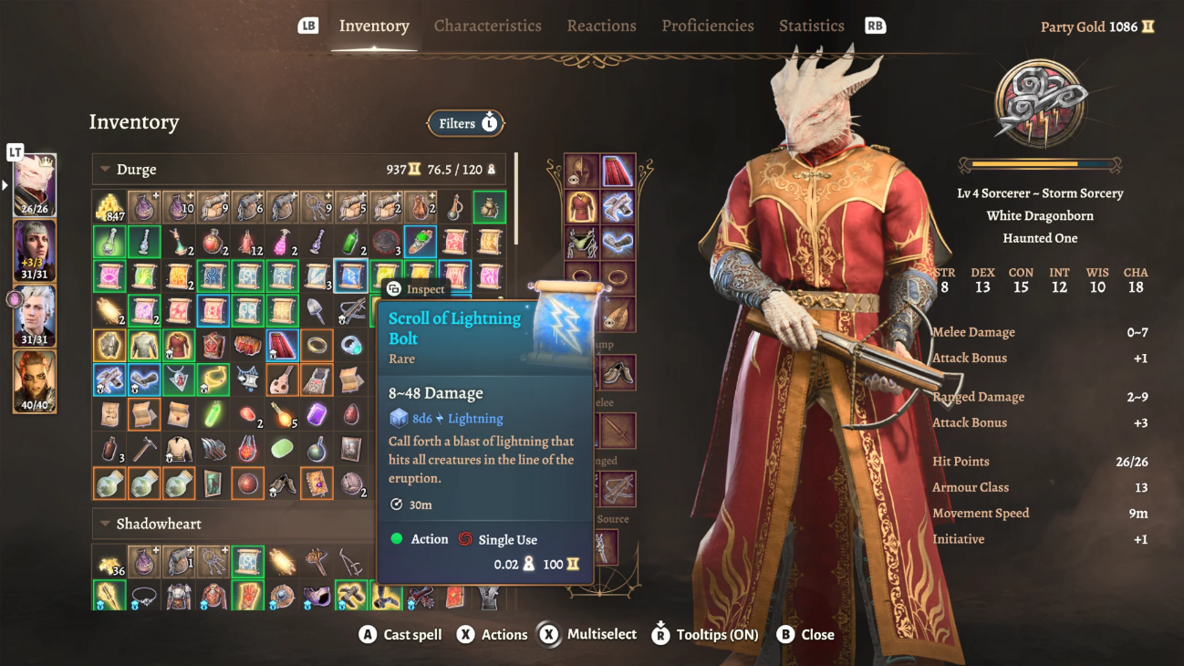
- Left Panel: Circular emotion wheel showing affective state of each alien
- Right Panel: Player character info and emotional footprint on the alien

- Technical Architecture
3.1. Game Engine
- Unity 6.0 (URP)
- Visual Studio 2022 (C# scripting)
3.2. AI Modules
A. Reinforcement Learning Model
- RL Agent trained with Unity ML-Agents
- Reward signal shaped by:
  - Alignment with diplomatic tone
  - Increase in positive emotional weights (e.g., joy, calm)
  - Penalty for negative affect (anger, fear)
B. Dialogue Planner
- Hybrid GOAP + LLM pipeline
- RL defines high-level intent ("de-escalate", "persuade")
- LLM (fine-tuned) generates response within intent, respecting emotion bounds
C. Emotion Engine
- Affect dynamics built using PAD / Inside Out blend
- Affect transitions animate with Unity Timeline & Animator
- Emotion state used to dynamically weight GOAP actions
D. Context Filter
- Uses dictionary of context-approved vocabulary
- Optional: lightweight LLM fine-tuned for sci-fi universe context filtering
E. Offensive Language Guard
- Regex profanity filters
- Safety wrapper around LLM to reject toxic outputs (OpenAI/Deepmind policies)

- Evaluation and Experiment Design
Setup:
- 3 Alien Leaders (each on a planet):
  - 2 Use affect-driven AI (with different models)
  - 1 Uses scripted dialogue tree (baseline)
Metrics:
- Believability (user rating post-interaction)
- Emotional alignment (does the alien react coherently?)
- Engagement (time spent per interaction)
- Novelty (number of unique valid dialogues per player)

- Development Phases
Phase 1: Prototype Foundation
- Unity base game setup (UI layout, navigation, camera)
- Create planet system map and transition logic
Phase 2: Dialogue System Setup
- Scripted dialogue system for baseline NPC
- Integrate GOAP framework and test with basic RL (no emotions yet)
Phase 3: Emotion System Integration
- Implement PAD emotion engine
- Connect to NPC state machine and visual feedback (animations)
Phase 4: RL + Emotion Fusion
- Train Unity ML-Agent on goal-driven conversational responses
- Feed affective state to adjust rewards and actions
Phase 5: Evaluation & Polish
- Conduct user testing
- Implement UX polish, animation transitions
- Export for WebGL or Windows

- Tools and Frameworks
- Unity ML-Agents Toolkit
- OpenAI API (or local fine-tuned LLM)
- MediaPipe or FastText for sentiment/emotion inference
- DOTween / Animator / Timeline for transitions
- Firebase / Google Sheets for logging user interactions (optional)
- Final Remark
This project will serve as an innovative demonstration of how affect-driven reinforcement learning can create emotionally responsive, believable NPC interactions that rival and exceed traditional scripting. It blends game development, affective modelling, and conversational AI into a novel interactive experience with research significance.

What’s been done so far:
- Design and implement the UI of the game for a conversation with the alien
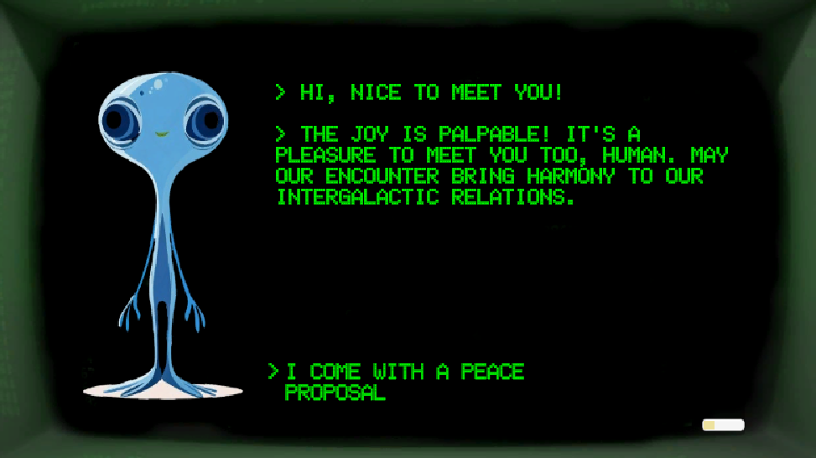
- For text analysis based on the user input, I have integrated into the Python chat server:
  - SpaCy API for Named Entity Recognition (NER) to detect and classify information in the text of the user input:

    - PERSON: People, including fictional.
    - NORP: Nationalities or religious or political groups.
    - FAC: Buildings, airports, highways, bridges, etc.
    - ORG: Companies, agencies, institutions, etc.
    - GPE: Countries, cities, states.
    - LOC: Non-GPE locations, mountain ranges, bodies of water.
    - PRODUCT: Objects, vehicles, foods, etc. (Not services.)
    - EVENT: Named hurricanes, battles, wars, sports events, etc.
    - WORK_OF_ART: Titles of books, songs, etc.
    - LAW: Named documents made into laws.
    - LANGUAGE: Any named language.
    - DATE: Absolute or relative dates or periods.
    - TIME: Times smaller than a day.
    - PERCENT: Percentage, including ”%“.
    - MONEY: Monetary values, including unit.
    - QUANTITY: Measurements, as of weight or distance.
    - ORDINAL: “first”, “second”, etc.
    - CARDINAL: Numerals that do not fall under another type.

- Sentiment Analysis of the text using TextBlob
- Emotion Classification using HuggingFace.
- The output is something like:
Emotion results raw output: [[{'label': 'joy', 'score': 0.9399862289428711}, {'label': 'surprise', 'score': 0.03326673060655594}, {'label': 'neutral', 'score': 0.020288951694965363}, {'label': 'sadness', 'score': 0.0032197856344282627}, {'label': 'anger', 'score': 0.0018657272448763251}, {'label': 'disgust', 'score': 0.000726335565559566}, {'label': 'fear', 'score': 0.0006463375757448375}]]
Redacted input: Hi, nice to meet you!
Entities: []
Polarity: 0.75
Emotion: joy (0.9399862289428711)
Expeceted behavior:

You are Xarnon, the alien leader of the planet Vireth.
Player emotion detected: joy with a score of 0.9399862289428711.
Player sentiment polarity: 0.75 and subjectivity: 1.0.
Player text was: Hi, nice to meet you!
You should answer with joy and agreement, sounding cheerful and optimistic!
Respond as Xarnin, in-character, diplomatic, wary of humans, collectivist culture.
Keep your answer concise and very briefly. Use up to 50 tokens.
Always end your response with a complete sentence.

127.0.0.1 - - [05/Jul/2025 17:23:45] "POST /chat HTTP/1.1" 200 -

- Currently trying to work on a shader or any form of creating a background which gives the impression that we are in the middle of the galaxy (stars that blink).

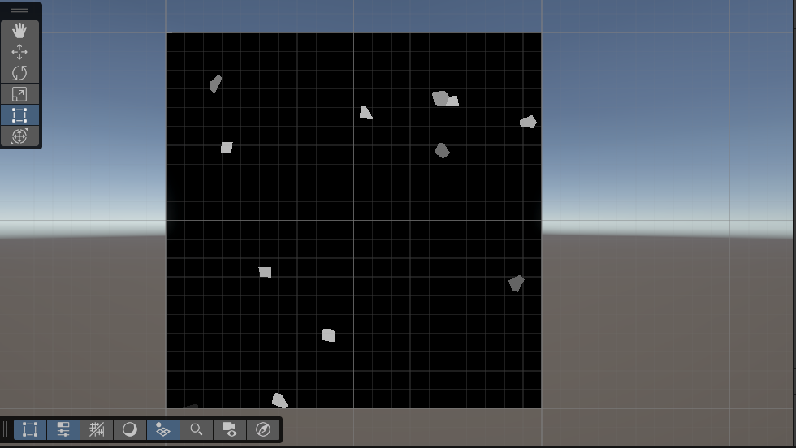

- Imported the spaceship model into Unity, as well as different planet textures which would be randomized.

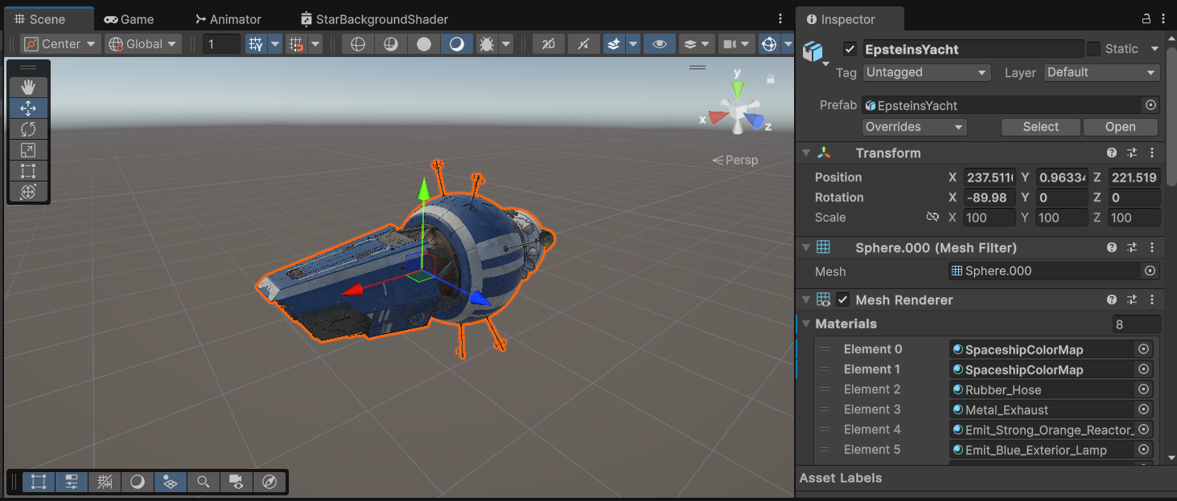
- Integrated Firebase for Logs (though needs implementation), using this video:
https://www.youtube.com/watch?v=59RBOBbeJaA&ab_channel=SoloGameDev

